

**AC POWER CONTROLLER WITH PROGRAMMABLE INTERFACE**

**Bachelor of Technology**

**In**

**DEPARTMENT OF ELECTRICAL AND ELECTRONICS ENGINEERING**

Submitted to

**VIT BHOPAL UNIVERSITY (M. P.)**

**Submitted by**

**NAME OF STUDENT- REGISTRATION0 NO**

**YASH CHANDAK – 20BAC10026**

**ANIKET VERMA – 20BAC10042**

**AARTI AJNAR – 20BAC10027**

Under the Supervision of

GUIDE NAME

DR. NARENDRA BABU

**SCHOOL OF ELECTRICAL & ELECTRONICS ENGINEERING**

**VIT BHOPAL UNIVERSITY**

**BHOPAL (M.P.)-466114**

**Month –Year - DECEMBER 2021**

© VIT Bhopal University – Year 2021



**VIT BHOPAL UNIVERSITY, Bhopal**

SCHOOL OF ELECTRICAL & ELECTRONICS ENGINEERING

**DECLARATION**

I hereby declare that the Dissertation entitled “*AC POWER CONTROLER WITH PROGRAMMABLE INTERFACE*” is my own work conducted under the supervision of *DR NARENDRA BABU Designation, Name of Department* at VIT Bhopal University, Bhopal.

I further declare that to the best of my knowledge this report does not contain any part of work that has been submitted for the award of any degree either in this university or in other university / Deemed University without proper citation.

*YASH CHANDAK- 20BAC10026*

*ANIKET VERMA – 20BAC10042*

*AARTI AJNAR – 20BAC10027*



**VIT BHOPAL UNIVERSITY, Bhopal**

SCHOOL OF ELECTRICAL & ELECTRONICS ENGINEERING

**CERTIFICATE**

This is to certify that the work embodied in this project report entitled **“AC POWER CONTROLER WITH PROGRAMABLE INTERFACE ”** has been satisfactorily completed by **Mr. YASH CHANDAK (20BAC10026),ANIKET VERMA (20BAC10042)**, **AARTI AJNAR(20BAC10027)** in the School of Electrical & Electronics Engineering of at VIT Bhopal University, Bhopal. This work is a bonafide piece of work, carried out under my/our guidance in the School of for the partial fulfilment of the degree of Bachelor of Technology.

|  |  |
| --- | --- |
|  | ***Name of Guide***  ***DR. NARENDRA BABU*** |
|  |
|  |  |
| Forwarded by | Approved by |
|  |  |
| ***DR.SOUMITRA K NAYAK*** | ***Dr. S.Poonkuntran*** |
| **Program Chair** | **Associate Professor & Dean** |

**Acknowledgement**

In the first place I would like to record my gratitude to “***DR NARENDRA BABU*”** for his supervision, advice, and guidance from the very early stage of this thesis work as well as giving me extraordinary experiences throughout the work. Above all and the most needed, he provided me unflinching encouragement and support in various ways. His words have always inspired me to work in an efficient and comprehensive way. I would like to thank him for his constant encouragement that enabled me to grow as a person. His presence has definitely improved me as a human being.

I express my gratitude towards “**Dr. S. Poonkuntran** Professor and Dean of School of Electrical and Electronics Engineering Department, VIT Bhopal University, Bhopal, for providing me all the help and permitted me to work in the laboratory with no time limits.

I shall ever remain indebted to “**Dr. U Kamachi Mudali”,** Vice Chancellor, VIT Bhopal University,for providing me institutional and administrative facilities during my project work at VIT.

I am very thankful to all

**Table of Contents**

**Contents**

* **INTRODUCTION**
* **OBJECTIVE**
* **PROPOSED METHODOLOGY**
* **CIRCUIT DIAGRAM**
* **LIST OF COMPONENT \SOFTWARE \TOOL USED**
* **WORK PLAN TILL NOW**
* **VIRTUAL MODE EXPLANATION OF PROJECT**
* **PLANNING**
* **EXPECTED OUTCOME**
* **CONCLUTION**

**INTRODUCTION:**

* **The firing angle control of thyristors is done by the microcontroller, according to the desired percentage entered by the user. Based on this input the microcontroller will automatically adjust the power delivered to the lamp through a solid state switching mechanism.**
* **This system overcomes the faults in the present system and provides solution for light illumination control.**
* **This system is built by using an 8051 microcontroller and based on the principle of firing angle control of**
* **thyristors, which in turn can control the illumination of lamp. An LCD display unit is used, which displays entered percentage of the illumination through a matrix keypad**.

**OBJECTIVE:**

* The main objective of this work is to vary the percentage of power supply by means of phase angle variation of the conduction period through the setting of different firing times corresponds of different firing angles.

**At the end of the work we will able to :-**

* Have the full understanding of firing angle.
* Understand the application of TRIAC and SCR in power electronics.

**METHODOLOGY:**

* **Ac power control with thyristor usinig microcontroller is designed to control AC power flow across load .**
* **This project is designed using AT85s52 microcontroller and zero crossing detection circuit**
* **Phase angle control method is used for AC power control with thyristor .**
* **Thyristor is used as a switch to control flow of power**
* **AT85s52 microcontroller is usd to detect zero crossing and to generate pulse signals at a specific angle for thyristors .**

**CIRCUIT DIAGRAM:**

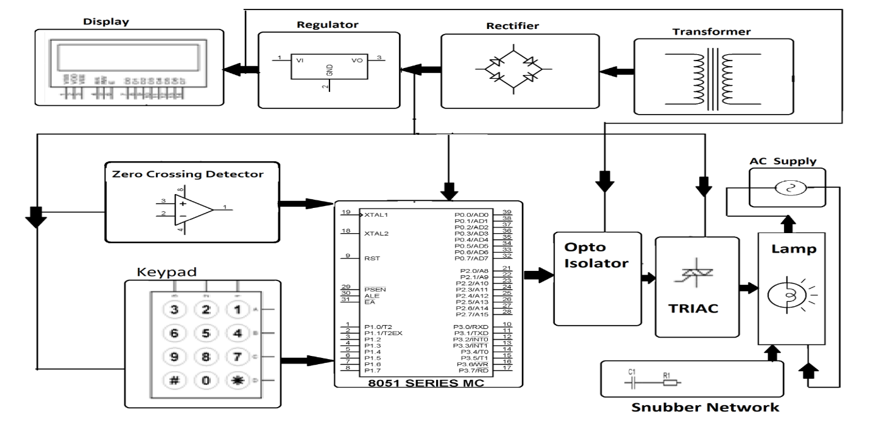

**LIST OF COMPONENT SOFTWARE USED:**

**Hardware Specifications**

* **8051 series Microcontroller**
* **Transformer**
* **LCD**
* **Diodes**
* **keypad**
* **TRIAC**
* **Opto Isolator**
* **Lamp**

**Software Specifications**

* **Keil µVision IDE**
* **MC Programming Language:**
* **Embedded C**

**WORK DONE FROM REVIEW 1 TO FINAL:**

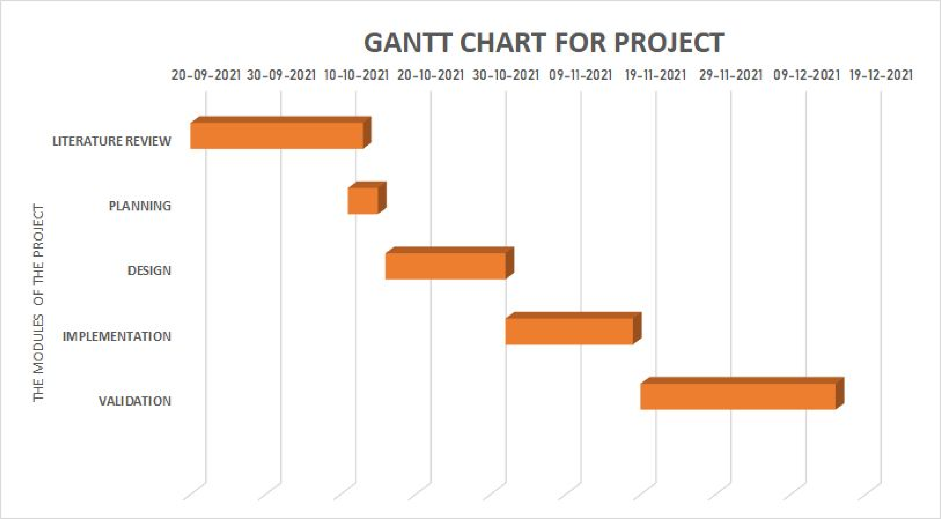

GANTT chart representation of the work plan

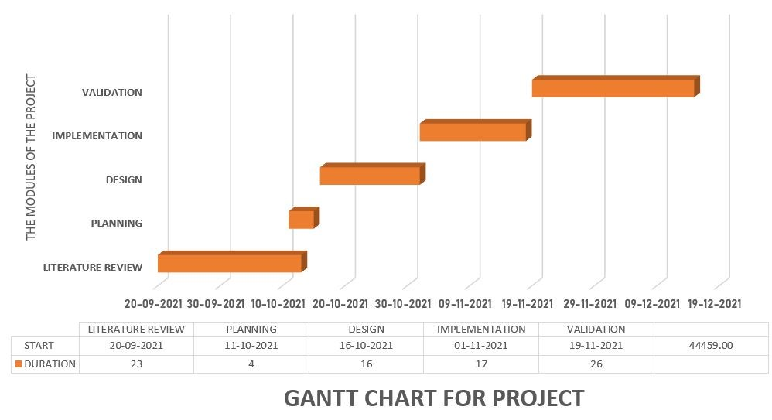

**REVIEW 2**

**Review 1**

**PROJECT EXPLANATION**

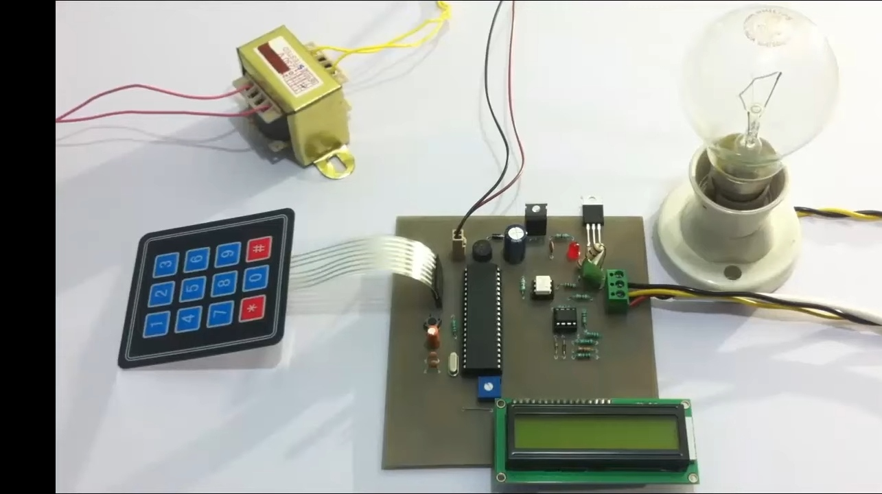

* **THIS IS OUR WORKING MODEL IMAGE .**
* **LETS PUT ON THE SWITCH .**

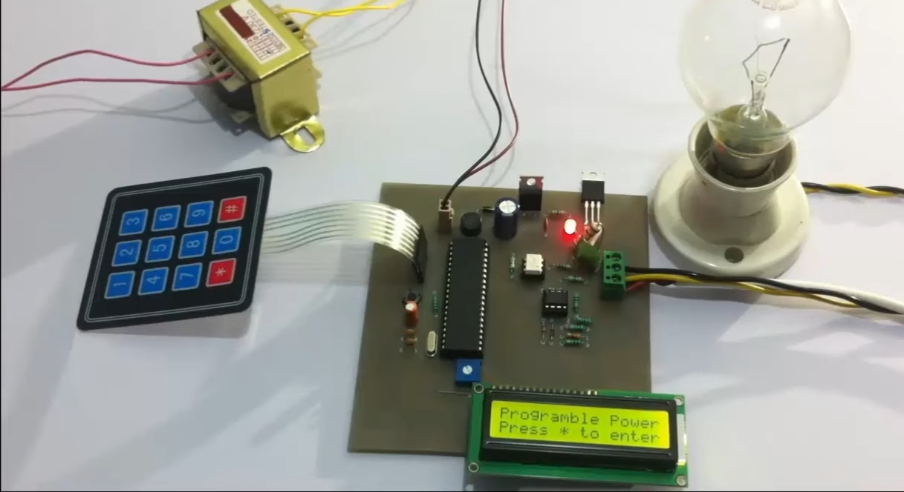

* **When the switch on the red light of model on .**
* **First we have to enter * from keypad to enter the required percentage of intensity of light.**

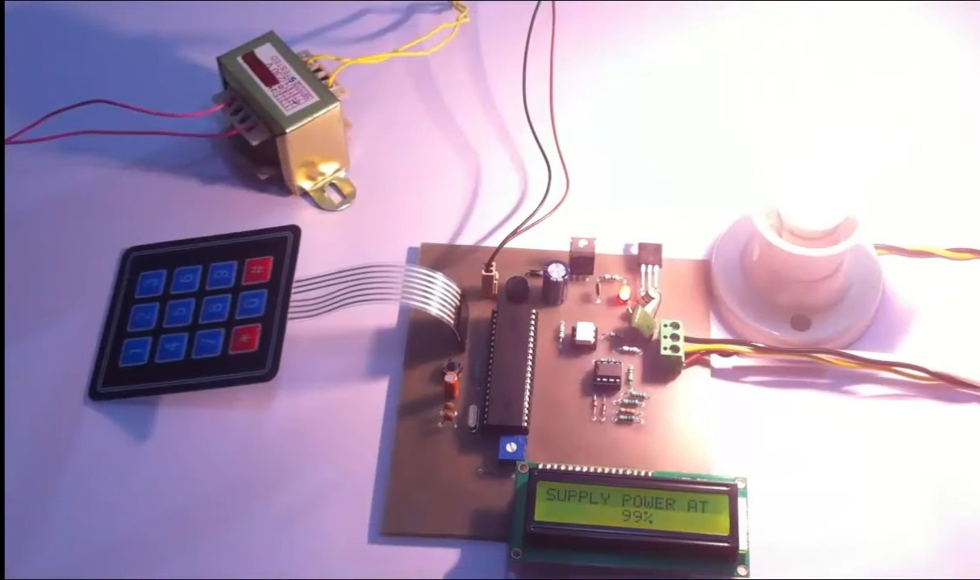

* **Lets put 99% of the intensity and see the intensity of light.**
* **The bulb glow at the highest intensity,**
* **To cancel the operation we need to press * from keypad and again press * to give new percentage**



**Again we have to give a required percentage from keypad and see the intensity of light**

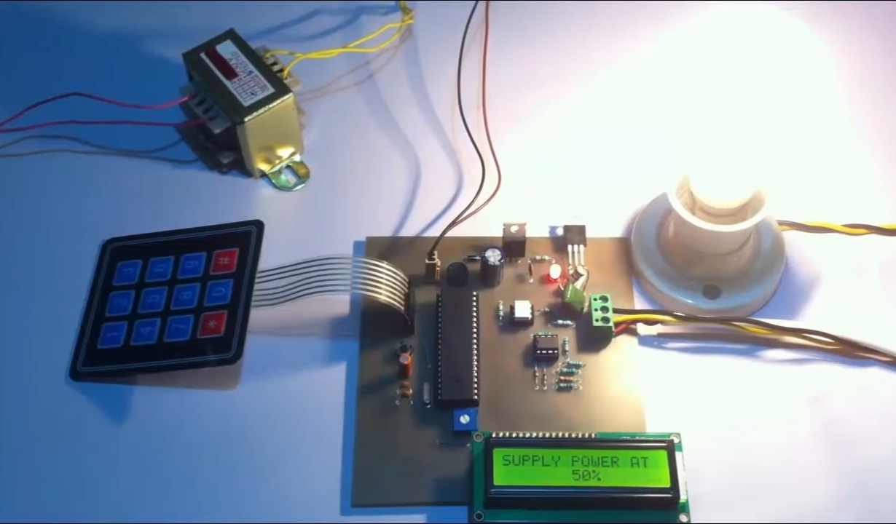

* **Lets say we input * and change the required percentage.**
* **Lets say 50 % power**

**PLANNING:**

* **As mentioned earlier, our trained model is ready and is working successfully.**
* **As for what's now the model must be able to detect all the intensity for required percentage signs and give relevant output with respect to that.**
* **The work done till now has all been a smooth sail right from downloading the data set to training the model, however we were successfully able to eradicate the errors and bugs in the project that we had written till now.**

**EXPECTED OUTCOME**

* **The work is on contolling the AC power by using the concept of firing angle control of thyristors .**
* **One can enter the required percentage of power supply through a keypad .**
* **The input is provided to a miocrocontroller of 8051 family that initiate the firing angle to adjust the load power .**
* **For matching the power to the required one, aTRIAC is used in series with the AC load .**
* **A LCD screen is used to display the power percentage that is provided by the user**

**CONCLUTION**

* This work is used at controlling the AC power by using the concept of firing angle control of thyristors.

* With this device one can enter the required percentage of power supply through a keypad

**References**

1. **Lee Siang Tat, YiauwKahHaur “AC Power Controller By Using Microcontroller”. ISSN:2180-1843 eISSN:2289-8131.Vol.8 No.12.**
2. **David Margulies, Clifford E. Felder, Galina Melman and Abraham Shanzer “A Molecular Keypad Lock: A Photochemical Device Capable Of Authorizing Password Entries”. Cite This:J.Am.Chem.Soc.2007,129,2 347-354 Publication date: December 19,2006.https://doi.org/10.1021/ja065317z.**
3. **Web ProForum Tutorials, “Global System for Mobile Communication (GSM)”, The International Engineering Consortium, http:// www.iec.org.com USA.**
4. **Gunnar Heine, “GSM Networks: Protocols, Terminology, and Implementation”, British Library, ISBN:0-89006-471-7, London, 1999**